**Senior Project**

**Student Name:** Tony Karam

**Student ID:** 20112214

**Project**

My idea for my senior project is to present a modification to a game called Counter Strike 1.6 using AmxModX (the add-on used to hook and modify the game’s .dll files). I am thinking of making an achievements plugin for several servers that store each payer’s progress and saves it in a database, where that player can later access a specific website (that I will be making) to see his progress or look at new possible achievements.

**EER**

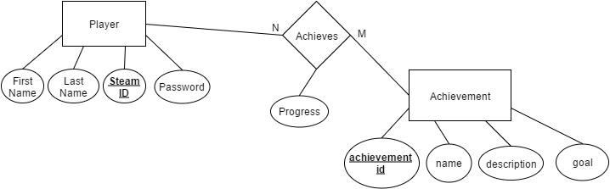

* Player is the account of every person present in the database. It will store the player’s first name, last name, steam_id, and password.
  + The steam_id will not be editable, it will be obtainable automatically when the player connects to the server and sets up a password.
  + The password will be set when he joins the server and sets a new password.
  + The player can then login to the website with his steam_id and password to set his first name and last name.
* Achievement is the achievement that the player will be able to get. It will contain the achievement’s id, name, description, and the goal that the player has to reach in order to earn that achievement.
  + The id will be a sequential identification number that is automatically added each time a new achievement is added.
  + The name will be a user friendly identifier to display on the website.
  + The description will be a small paragraph and/or sentence to explain briefly what the player has to get in order to earn that achievement.
  + The goal will be to number of times the user has to achieve a certain task to receive that achievement.
* Achieves is the act of achieving a specific achievement by the player. It will hold the player’s steam_id, the achievement’s id, and the progress that the player has got so far.
  + Progress is the amount of time the player has achieved the achievement’s task. It has to reach the achievement’s goal in order for the player to fully earn that achievement.

**Relation Tables**

Player

|  |  |  |  |
| --- | --- | --- | --- |
| **steam_id** | first name | last name | password |

Achievement

|  |  |  |  |
| --- | --- | --- | --- |
| **achievement_id** | name | description | goal |

Achieves

|  |  |  |
| --- | --- | --- |
| **steam_id** | **achievement id** | progress |